# TES Based

Sum of literature clusters + selected genes

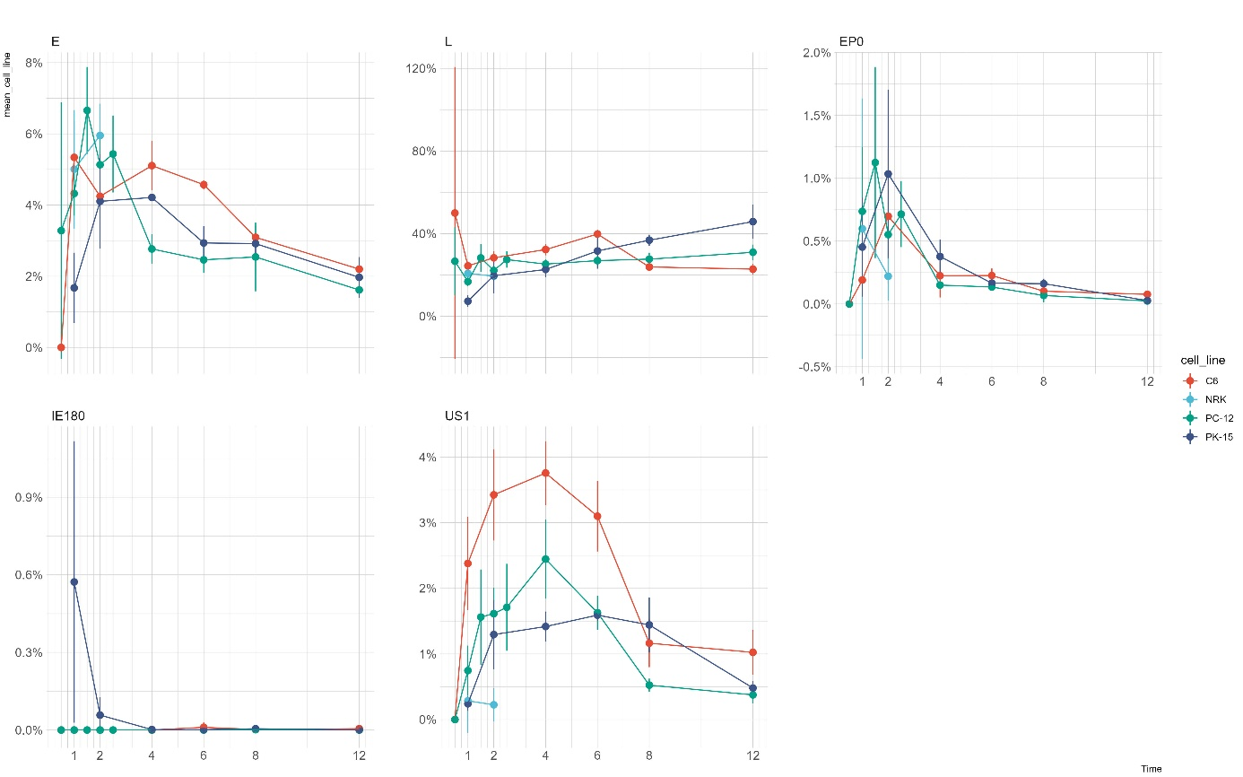

Ratio of selected genes to each other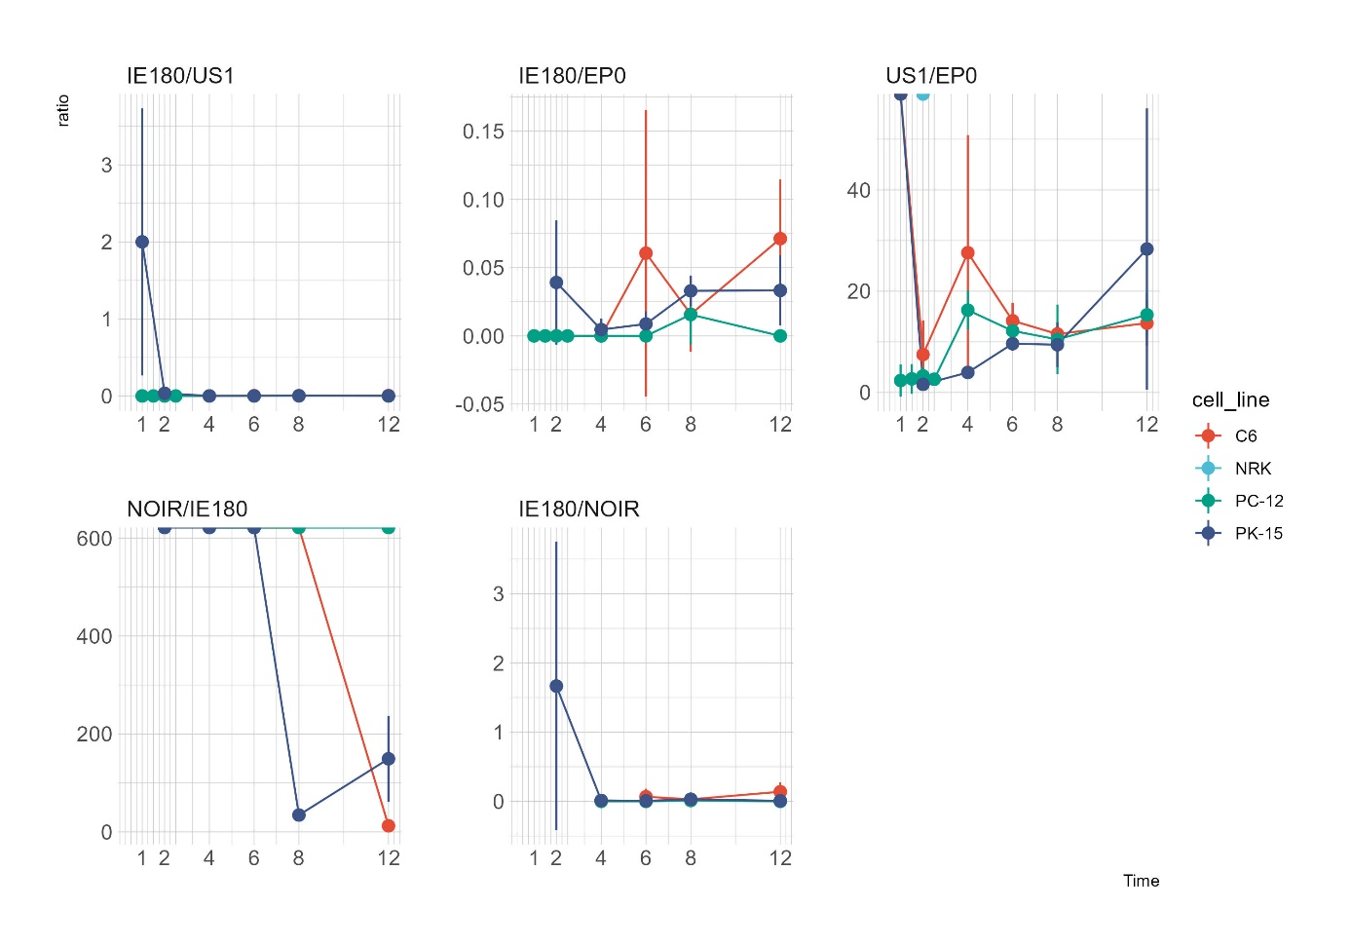

# TSS Based

Sum of literature clusters + selected genes

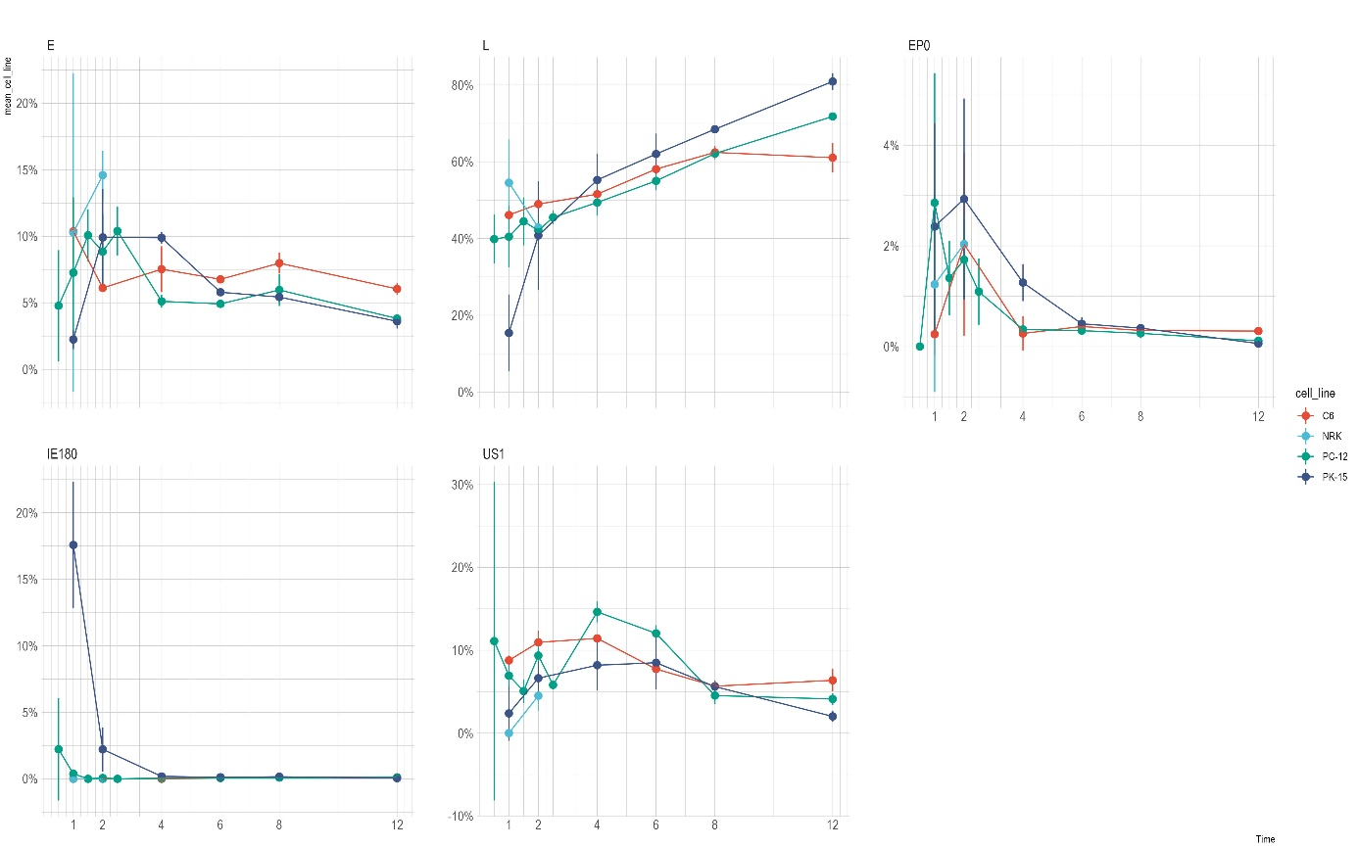

Ratio of selected genes to each other

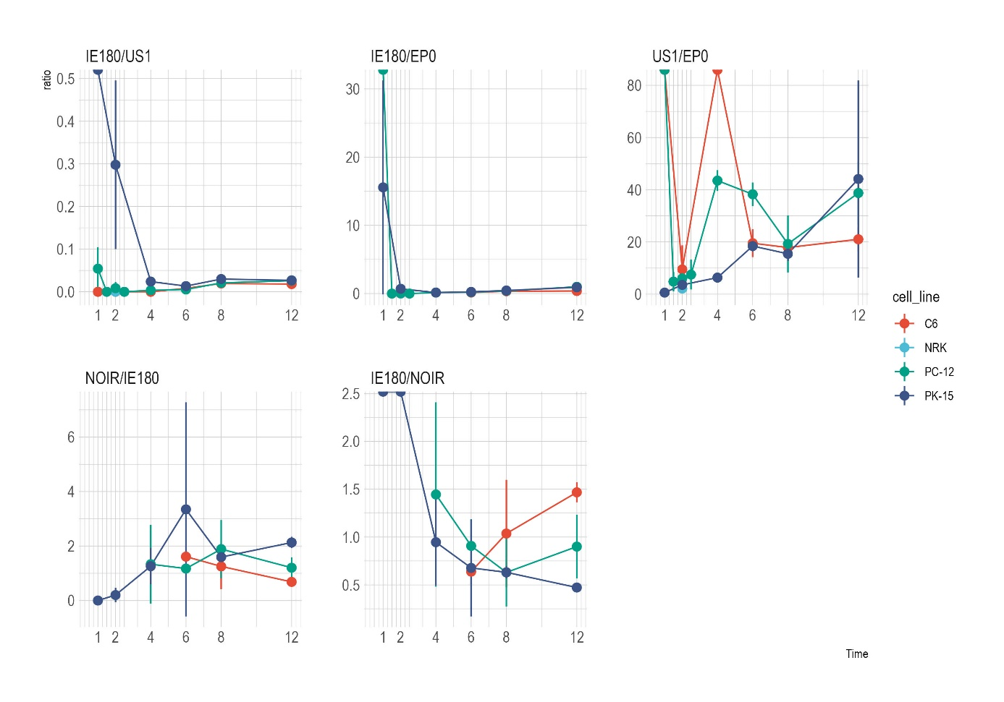

## TSS and TES Based

Sum of literature clusters + selected genes

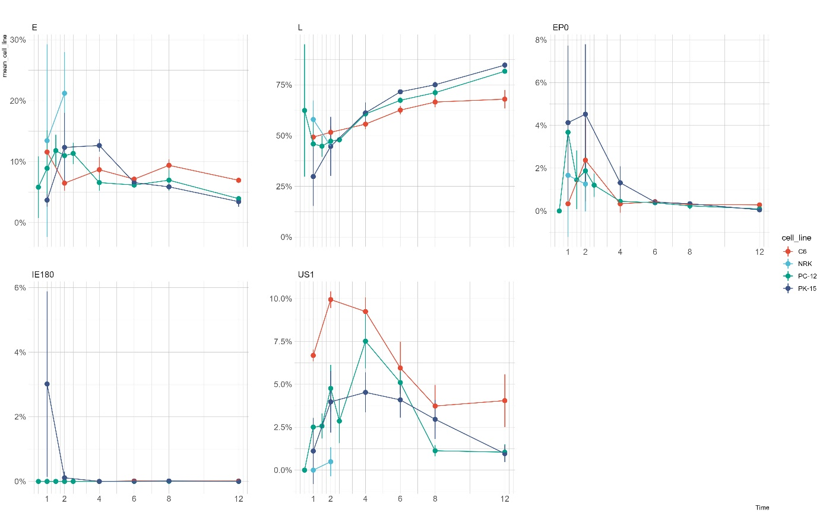

Ratio of selected genes to each other

